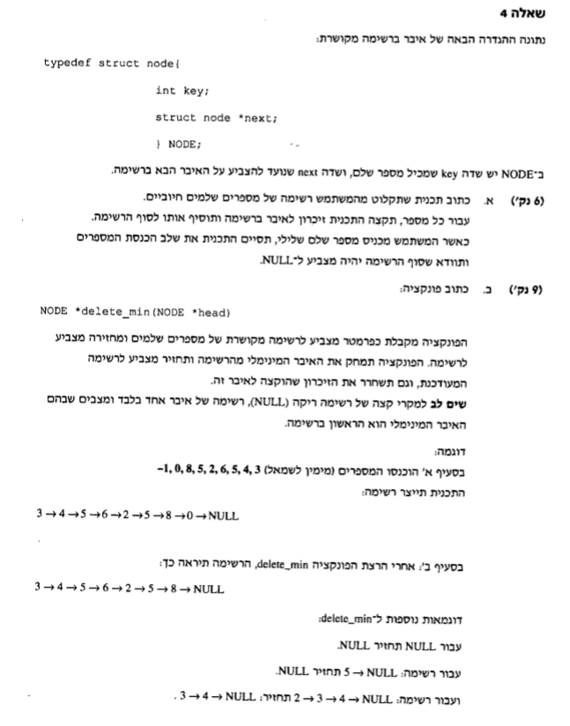

typedef struct node {

int key;

struct node *next;

}NODE;

NODE *newNode(int key)//function to create new node

{

NODE *temp = NULL;

temp = (NODE*)malloc(sizeof(NODE));

temp->key = key;

temp->next = NULL;

return temp;

}

void addNode(NODE *head, NODE *node)

{

NODE *current = head;//create new pointer equal to head

while (current->next)//runs until next is null

current = current->next;//move current to the next node in the list

current->next = node;//puts node into next

}

NODE *delete_min(NODE *head)

{

NODE *min = head;

NODE *current = head;

while (current->next)

{

if (min->key > current->key)

{

min = current;

current = current->next;

}

else

current = current->next;

}

if (min->key > current->key)

{

min = current;

current = current->next;

}

else

current = current->next;

return min;

}

void main()

{

int num;

NODE *head = NULL;

NODE *temp=NULL;

NODE *min = NULL;

printf("insert number:");

scanf("%d%*c", &num);

head = newNode(num);

while (num >= 0)

{

temp=newNode(num);

addNode(head, temp);

printf("insert number:");

scanf("%d%*c", &num);

}

min = delete_min(head);

printf("minimum number is : %d\n", min->key);

}